COS225 Assg #4 Name _____________________
Due: Friday 3/2/18
Late: Friday 3/9/18
Readings: Chapter 19 and lectures on stacks and queues

Create a Word or RTF or PDF document (no other formats please) with answers to Part I questions and the screen shots of program output.

Part I. (20 pts.)

1. (6) Write a generic method peek2 that could be passed a stack of any type and returns the item that is one down from the top. If the stack does not have 2 items, the method returns the null reference. Note the method does not alter the stack it is passed in any way.

public class TestPeek2 {
public static void main(String[ ] args) {
ArrayStack<Integer> istack= new ArrayStack <> ( );
ArrayStack<String> sstack= new ArrayStack <> ( );
ArrayStack<Double> dstack= new ArrayStack <> ( );

istack.push(10); istack.push(20);
sstack.push("red"); sstack.push("blue"); sstack.push("yellow");
dstack.push(1.5);

Integer i = peek2(istack);
if (i == null) System.out.println ("Integer stack does not contain at least 2 elements");
else System.out.println ("Integer stack second item is " + i);

String s = peek2(sstack);
if (s == null) System.out.println ("String stack does not contain at least 2 elements");
else System.out.println ("String stack second item is " + s);

Double d = peek2(dstack);
if (s == null) System.out.println ("Double stack does not contain at least 2 elements");
else System.out.println ("Double stack second item is " + d);
}
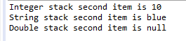
// write method peek2

2. (6) Using the ArrayStack class developed in lecture, list the output of each line.

ArrayStack<Integer> s = new ArrayStack<Integer> ( );
s.push (20); s.push (40); s.push (50);

System.out.println (s.size( ));
System.out.println (s.peek( ));

s.push (80); s.push (30); s.pop ( ); s.push (10);

while (!s.empty( ))
{ System.out.print (s.peek ( ) + " ");
s.pop ( );
}

3. (4) Using the LinkedStack code, draw a picture of the linked list below after a pop( ) method. Draw the nodes and values in the next field (arrow or null). Reference top should use an arrow to point to its node. If a node has been garbage-collected, do not include it in the picture.

top |  | 15 |  |  | 25 |  |  | 10 | null

Your picture:

top:

4. (4) Using the ArrayQueue code and the original state shown below, draw a picture of the array after an enqueue of value 5. Show items in the queue and indicate the value in front and rear.

 | 25 | 10 | 30
0 1 2 3 4
front: 1 rear: 4

Your picture:

0 1 2 3 4

front: ________________ rear: ________________

Part II: (80 pts) This program will compute income from a small parking lot. It uses a stack to hold cars in LIFO order. Use one of the stack classes developed in lecture or the Java Stack class. A company rents a 5-car alley for parking. The alley is so narrow that the only egress is at the top, forcing vehicles to be removed one at a time in order to retrieve an internal one. Vehicles are temporarily parked on the street in metered slots until they can be returned to the alley. Research the LocalTime class and use its methods to store and manipulate time.

alley is a stack

street metered parking

One day’s data set is available in file lot.txt.

Arrival/Departure Code: arrival ("A") or departure ("D")
License (ex. "BOSS")
Arrival/Departure time integer hour blank minute (ex. 10 30 or 21 45)

Version 1: Console application
Read in lines of the data files and recreate the movement of cars in and out of the parking lot. Vehicles are charged $5.00 per hour for the duration of their stay. Partial hours are rounded up. Cars parked temporarily on the one way street pay a $0.50 meter fee. Cars then drive around the one way street and repark in the parking lot in a First In First Out fashion. The first car parked on the one-way street is the first car returned to the parking lot. We will be studying queues next week; you can use an ArrayList for the metered parking and treat in FIFO fashion or add in a queue next week.

For each arrival report:

xxxxxx parked at xxxx
xxxxxx was turned away at xxxx – LOT IS FULL!

For each departure report:

xxxxxx left at xxxx paying $xx.xx
xxxxxx does not have a car in the lot

At the end of the day report sum of parking income and meter fees.
Design a Car class with data members:
- String license
- LocalTime arrival time

Car methods include:
- constructors
- accessors and mutators
- toString
- compareTo using the license as the key field (Car implements the Comparable interface.)

Design an application class with a main method to process cars. Turn in screen shot of output. Your name should appear on the first line.
- Write a static method fee which is passed two LocalTime objects and returns the parking fee.

Version 2: Graphics application
Report the output to TextField controls. Research methods to change visibility of controls. Your name should be in the title area. When button Next is clicked, process the next line from the file.
If it is an arrival report the license, status Arrival and time of arrival.
If it is an arrival but parking lot is full, report the license, status Rejected and time of arrival.
If it is a departure report the license, status Departure, time of departure, and customer charge.
When button Summary is clicked, report the sum of meter fees and sum of parking charges for all customers processed.

Sample Arrival: Sample Reject:
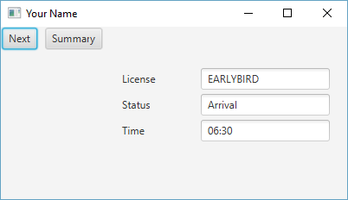
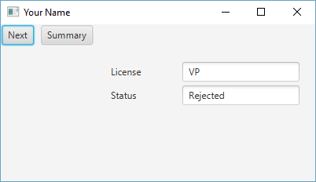

Sample Departure: Sample Summary:
